March 2026

Dear DAV leaders and members,

We’re sending our very best wishes for a productive and inspiring department convention.

This gathering is more than a date on the calendar—it reflects a year’s worth of hard work on behalf of veterans and their families, survivors and caregivers. It’s also a critical opportunity to focus on the challenges facing those we represent and to shape the path forward together. At a time when so many veterans are navigating complex transitions and evolving needs, your leadership matters deeply and will continue to matter long after this convention ends.

DAV’s strength has always come from dedicated members like you. The time you give, the advocacy you provide and the relationships you build in your communities create real, lasting impact. This annual convening offers space to take stock of what you’ve accomplished and to think boldly about how we can advance our mission in the year ahead.

We encourage you to participate fully in the sessions and conversations ahead. Reconnect with colleagues, welcome new faces, exchange ideas and challenge one another to think creatively. The connections formed and insights shared here will ripple outward into your work every day.

On behalf of your fellow members, thank you for your steadfast commitment. Decisions made during this convention will undoubtedly influence the lives of veterans and their families across your state. Service doesn’t end when a uniform comes off, and as veterans serving veterans, we remain united in purpose, compassion and determination.
Your work makes a difference. Keep leading with pride and purpose.
Sincerely,
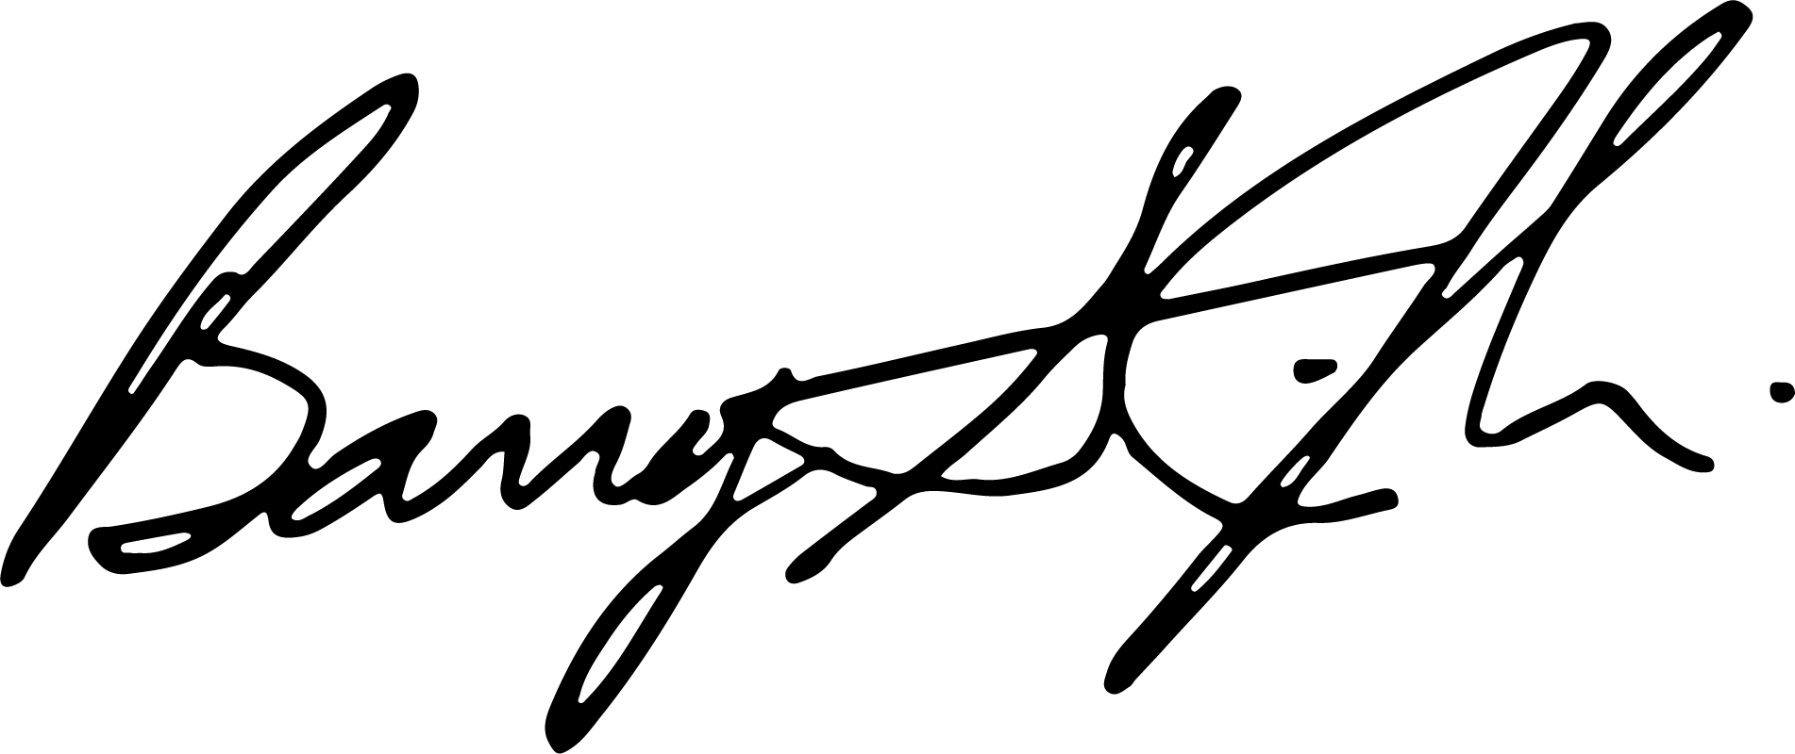
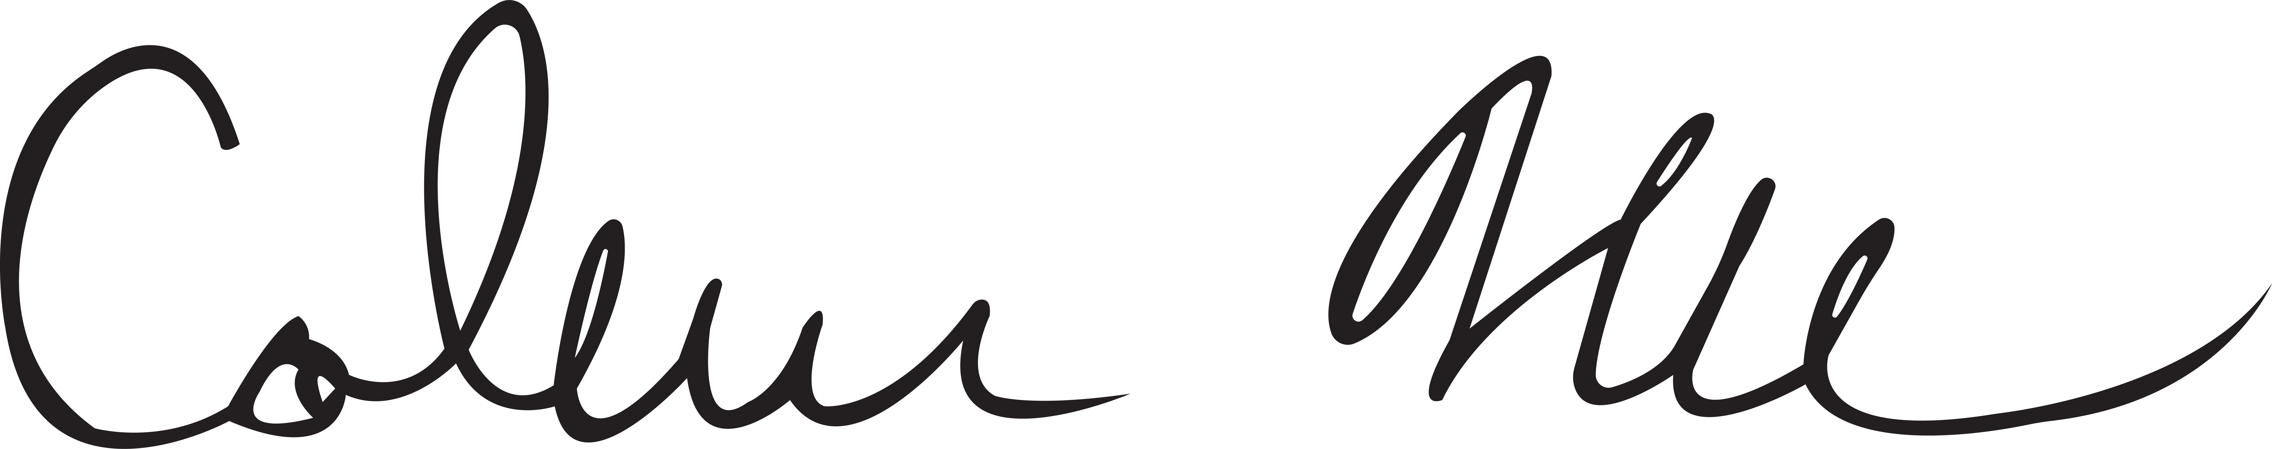
Coleman Nee Barry Jesinoski
National Commander National Adjutant and CEO

