March XX, 2024

Dear DAV leaders and members,

Together, we would like to send our heartfelt wishes for a successful department convention!

This event is the culmination of all the hard work you do throughout the year and helps bring attention to the issues that matter most to the veterans and families we serve. Our brothers and sisters need our support as much as ever, and we have the utmost confidence that you will continue to be there for them after the convention ends.

Your members are a vital part of DAV’s success, and your dedication to our cause enriches the lives of our brothers, sisters and family members who have sacrificed so much. This annual convention is a time to reflect on the year’s accomplishments as well as strategize on ways to work together to support veterans and their families.

We urge you to take part in the activities planned during your convention and enjoy the camaraderie of your fellow veterans and DAV members. It’s also a great opportunity for you to network and learn about the current initiatives other DAV chapters and Auxiliary units have going on.

On behalf of your fellow members, thank you for all you do. We understand the importance of the business conducted this week and how it will carry forward for veterans and their families in your communities in the coming year. DAV members know that the transition from the military never truly ends, and because we are veterans serving veterans, we do so from a place of great compassion and understanding.

Please continue your wonderful work and know we—and all the veterans and family members you serve—appreciate your unyielding efforts.

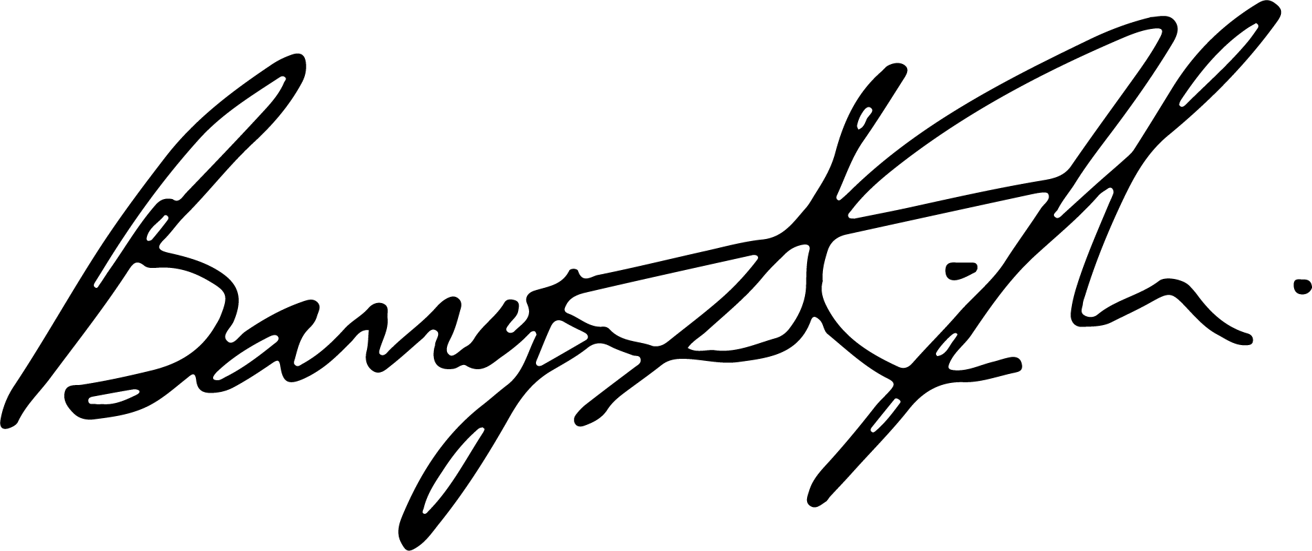
Sincerely,
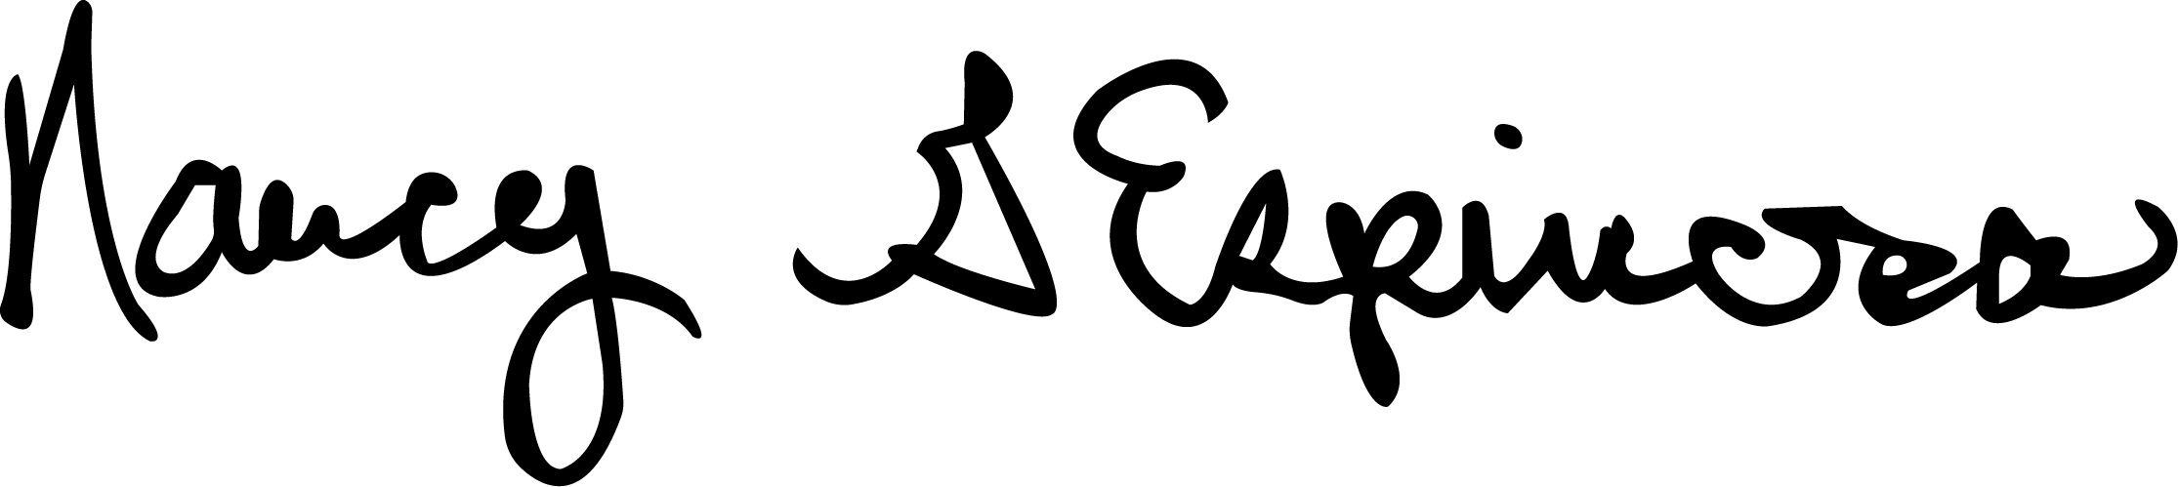

Nancy Espinosa Barry Jesinoski
National Commander National Adjutant and CEO

