March 11, 2022

Dear DAV Leaders and Members,

Together we would like to pass along our best wishes for yet another successful department convention!

All your hard work throughout the year helps to highlight and bring attention to the issues that mean the most to veterans and their families across the country and right here in your backyard. Our nation’s heroes need our support as much as ever. We both have the utmost confidence that you will continue to stand up for those who stood up for us—and those who stood alongside us.

Your members continue to be a vital component of DAV’s continued success, and your devotion to our cause enriches the lives of our brothers, sisters and family members who have sacrificed so much. Your annual convention is the time to look back on the year’s achievements as well as to discuss and work together on new initiatives that support veterans and their families.

We hope that you are able to take part in some of the activities planned during your convention and to enjoy the camaraderie of your fellow veterans, as well as learn about current initiatives of other DAV chapters and DAV Auxiliary units.

On behalf of your fellow members, thank you for all you do. We take heart knowing that your important business this week will carry the torch for veterans and their families in your communities again over the coming year. DAV members know how challenging the road to recovery can be, and because we are veterans serving veterans, we do so from a place of great compassion and understanding.

Please continue your great work and know we—and all the veterans and family members you serve—appreciate your unyielding efforts.

Sincerely,
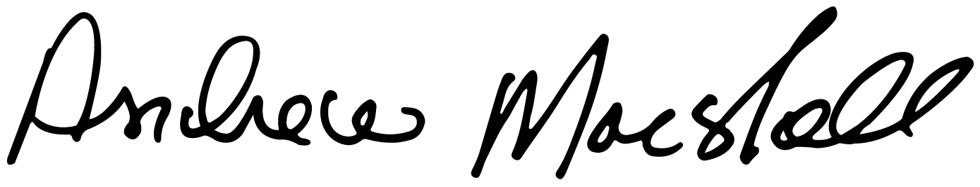
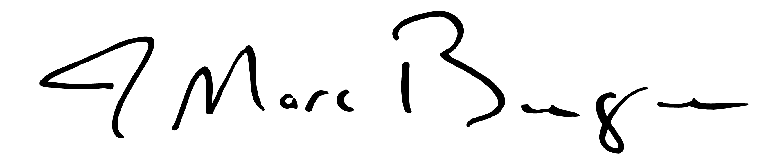

Andrew Marshall J. Marc Burgess
National Commander National Adjutant

